# ASSIGNMENTS ON DIGITAL MARKETING

**NAME: SANJAY.N**

**DEPARTMENT:** BE ELECTRONICS AND COMMUNICATION ENGINEERING

**COLLEGE:** 8151 DHANALAKSHMI SRINIVASAN INSTITUTE OF TECHNOLOGY

**NAANMUDHALVAN COURSE**: DIGITAL MARKETING

**NM ID: BF964049BFFDE04B23E42A7AB7DD6AD5**

# ASSIGNMENT 1:

Create a blog or website using Blogspot and WordPress. Customize The theme design and post new article with 500 words.

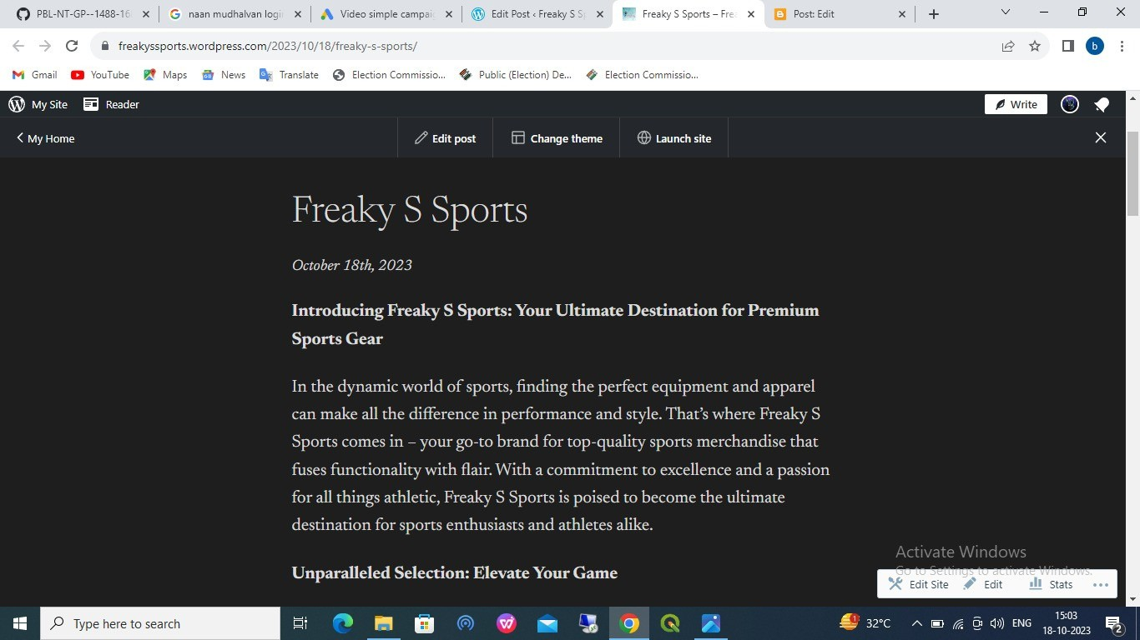

http://freakyssports.wordpress.com/2023/10/18/freaky-s-sports/

# ASSIGNMENT 2:

Create a new Facebook business Page and Post one social media poster for your brand.

https://www.facebook.com/profile.php?id=61550112398283&mibextid=ZbWKwL

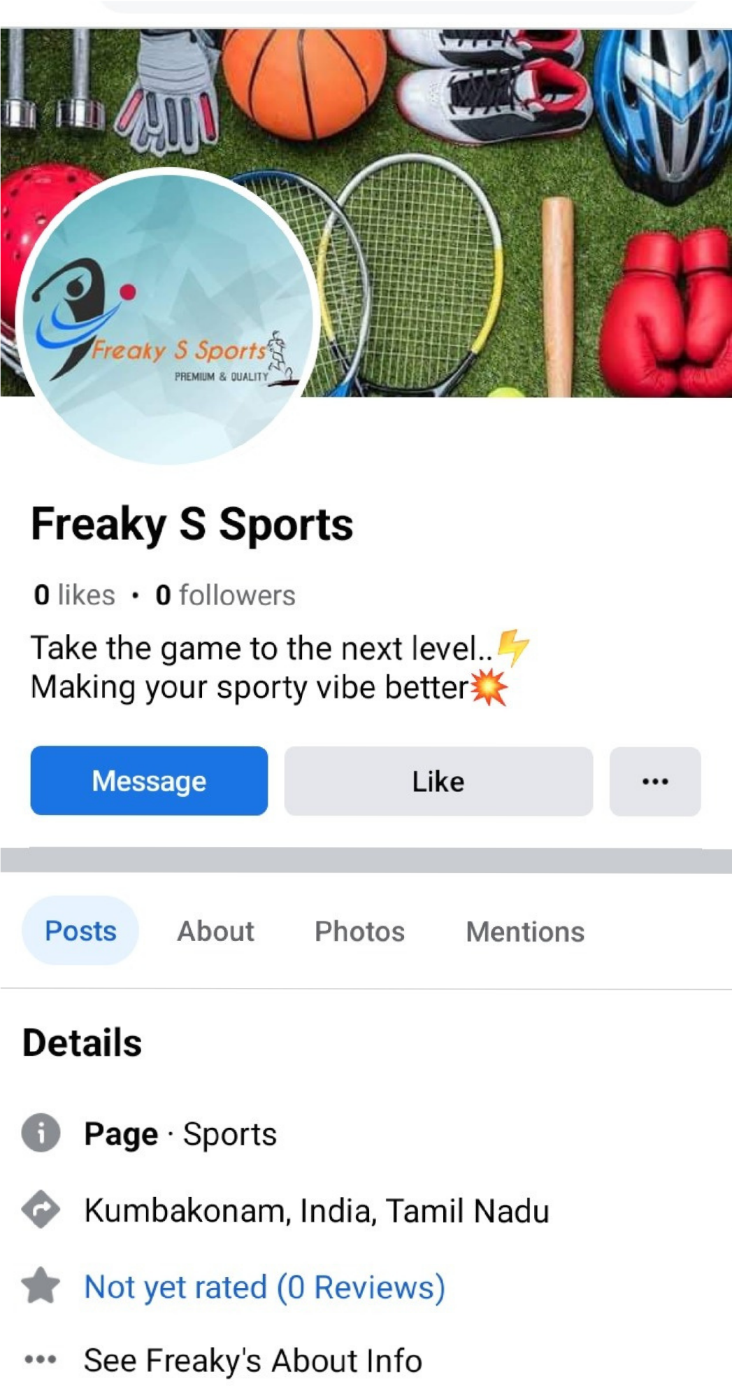

# ASSIGNMENT 3:

Create and design a social media advertisement poster using Canva.



# ASSIGNMENT 4:

Create email newsletter design using MailChimp or Canva tool.

